Deliverable 2: Customer Needs and Final Concepts

Team Members:
Andi Hennessey
Anthony Om
Chris Hampton
Jake Petrie
Jordan Wright
Vicenzo Infusino

Advisor:
Nadiyah Johnson

Date: 11/18/2022

Table of Contents
- Customer Needs and Final Concepts 3
- Data Collection 4
- Customer Statements and Interpreted Needs 6
- Benchmarking 12
- Needs Hierarchy 13
- Metrics 14
- Concepts 15

1 - CUSTOMER NEEDS AND FINAL CONCEPTS
List Customers. Describe each Customer in depth.
The team has identified four key stakeholders whose input has been taken into consideration for the construction of the BLK City Collective app. These stakeholders include young adults in the Milwaukee Community, users of the MKE Black application, businesses that are showcased on the MKE Black application (local small businesses), and local users who support the vision of MKE Black, but don’t have the application itself . The roles of these stakeholders are defined in the following subsections.
- Young adults in the Milwaukee community interested in local events/businesses
  - The main target group for the existing MKE Black website/application is for young adults in Milwaukee who have an interest in interacting with and supporting black owned local businesses. Similarly for the BLK City Collective website/application, young adults would be the ones who would primarily be utilizing it, so it is imperative that their needs and desires for an enhanced version of MKE Black directed towards other cities across the United States are met.
- Users of the MKE Black Website/Application
  - Users of the MKE Black website/application would provide a baseline of what they like about the current MKE Black website and also critiques of what they would like to see in an enhanced version of MKE Black. This stakeholder would provide information necessary to enhance the BLK City Collective’s website so that community members in other cities would utilize it.
- Businesses that are showcased on the MKE Black Application
  - Another main target group for the BLK City Collective app are the businesses that are showcased on the MKE Black application. These are business owners of locally owned Milwaukee businesses that are featured on MKE Black, and they would provide feedback on how they boost their businesses on the app. Furthermore, they can provide insight on what they would want to see in the enhanced BLK City Collective app in order to share their business information on the app.
- Local Users who support the vision of MKE Black, but don’t have the application itself.
  - Local users who support the vision of MKE Black, but don’t have the application itself are those people who just want to learn what Milwaukee has to offer and support the mission to empower underrepresented groups in the Milwaukee community. They can provide information about how they would bring representation to underrepresented groups and what they would like to see in the BLK City Collective app in order to become a user.

2 - DATA COLLECTION
Share how you will be collecting data for customer insights and explain what the data collection process looks like for the product itself.
Collecting Data Process: Customer Survey and Business Survey
A group of individuals in the Milwaukee area were surveyed for their familiarity with the MKE Black application and website. Furthermore, after expressing their familiarity with MKE Black, the surveyed group was asked to describe what they would like to see in the enhanced website, BLK City Collective, a website not meant to replace MKE Black but to extend its goals to other communities outside of Milwaukee. The overall objective of this survey was to gain ideas of what potential customers desire for the BLK City Collective App as well as features and qualities necessary for it to succeed. In order to gain better insights on customer needs, potential customers identified which qualities (like interactivity, accuracy, diversity of businesses, etc) were most important in order for them to have the best experience with the website/app. In addition, the customers identified important features that they would like to see on the website such as the types of businesses promoted, the location of the business, and the products they provide.
For the business survey, a group of businesses in the Milwaukee area were surveyed for the type of service they provide and if they are currently featured on the MKE Black application and website. Then, the businesses were asked to identify important features that the BLK City Collective website should provide in order for them to utilize it to promote their businesses. Also, businesses provided feedback on what information the BLK City Collective website should provide to the customers about their businesses as well.

3 - CUSTOMER STATEMENTS AND INTERPRETED NEEDS
Example:
Table 1: Interpretation of Customer Needs

# | Questions | Interpreted Responses
1 | Would you prefer to use the website or mobile app? (single response)
 | - Website: 22%  - App: 29.2%  - Both: 39%  - Neither 9.8% | There is substantial interest in both the website and mobile app. Our project will need to produce well-developed products in both domains.
2 | How would you like to interact with the businesses? If you have more specific interests, please type your answer in "Other". (multi response)
 | - Upvote/Like Button: 71.4%  - Comment to Business: 68.6%  - Favorites: 60%  - Direct messages: 57.1% | Consumers would like to see an upvote button as a way to view the popularity of a certain business. Additionally, having the ability to leave comments for the businesses and sending direct messages may be important features.
3 | What information would you like to see from the businesses featured on these applications? Examples: information and facts about a company, to products they have, contact info, etc.
 | Products they offer a link to the website and proximity of the business to me | Consumers would like functionality that makes access to the business contact info more convenient.
 | A map with locations, and a filter for type of location(i.e. food , fashion, service, etc.) | Consumers want the ability to see the location of businesses from a birds eye view. Consumers want to quickly be able to visually see how far they are from certain businesses and what routes they can take.
 | Facts who their partners are their values | Consumers want an overview of the businesses and their values. Consumers care about the mission of these businesses when deciding where to give their support. Businesses should have the ability to display a bio on the app/website.
 | Product information, facts about charities being ran by the company for a cause, reviews about the company’s products and new developments. | Consumers want to know what the business is offering and their mission overall. Consumers care about the small details when it comes to supporting local businesses. Understanding their focus, goals, and background is crucial for consumer decisions. Businesses should have the ability to display a bio on the app/website.
 | Hours, menu/products, images | Consumers want to see what the business offers and visually see what products/services are being offered. App/website should support external links and files from businesses. Consider things like a virtual menu or business website.
4 | Would you like to share businesses or info that you see from this technology on other social media? (for example, sharing it on Twitter or Facebook)
 | SMS, Instagram, Twitter, Facebook, Share button,Tiktok, Whatsapp | The app/website should have the ability to share business links on a variety of common platforms.
5 | What other features would you desire most from the app or website in order for you to use it?
 | Black event meet ups | Some consumers may want to utilize the app/website as a hub for everything related to Black social/business life in Milwaukee. Consider businesses, meetups, and possibly other events.
 | Tech support for the business, links to their media platforms, suggestion boxes | The app/website should display the contact information and social media handles or links for businesses. Additionally the app/website should give consumers the ability to send a message and/or leave a comment for businesses to review.
 | Filtering by service and/or product | Consumers want to be able to identify what products/services are being offered by each business. Furthermore, the app should allow consumers to quickly filter the businesses by their product/service/location category.
 | Color and voice feature | Consumers may like to see options to change theme color and to have an option to select a button to call a business.
 | Pictures and where it is located | Consumers want to visually see what products/services are being offered by these businesses. Additionally, they want to know where the businesses are located throughout Milwaukee
 | Search for keyword | Consumers want to easily find specific businesses or other business related info. App/website should have a search option.
 | No ads | Consumers do not like to be spammed with unwanted ads. Possible options to avoid ads would be to have a paid for app/website account.???? ASK TEAM!!
6 | Please rate how important the following options are for you to have the best experience with this technology. (1 - Not Important, 3 - Neutral, 5 - Very Important)  Interactivity: Having the ability to interact with other community members or business owners.
 | Average: 3.36 | The majority of consumers would like to be able to interact with the community and with the businesses. The app/website should incorporate functionality for comments/likes/messaging.
7 | Please rate how important the following options are for you to have the best experience with this technology. (1 - Not Important, 3 - Neutral, 5 - Very Important)  Accessibility: How easy it is to find what you are looking for within the application or website
 | Average: 4.61 | Consumers want ease of use. The app/website should have functionality to search/save specific businesses.
8 | Please rate how important the following options are for you to have the best experience with this technology. (1 - Not Important, 3 - Neutral, 5 - Very Important)  Accuracy: Keeping the content on the app and website up to date with current businesses.
 | Average: 4.69 | Consumers expect to see up-to-date information. Business info should be stored in a way that can be updated often and easily.
9 | Please rate how important the following options are for you to have the best experience with this technology. (1 - Not Important, 3 - Neutral, 5 - Very Important)  Diversity of Businesses: There are many different types of businesses featured on the app and website. (retail, restaurants, clothing, etc)
 | Average: 3.88 | The majority of consumers would like to see a list of diverse business types in the app/website. The app/website should be capable of hosting many different types of businesses.
10 | Please rate how important the following options are for you to have the best experience with this technology. (1 - Not Important, 3 - Neutral, 5 - Very Important)  Community Events: Different events that are being hosted across the city by local businesses are showcased on the website or app.
 | Average: 3.86 | The majority of consumers would find it useful/preferred to find community events in the app/website. The app/website should have the ability to showcase local events.
11 | What kind of communities/businesses would you like to see and connect with on the applications? (Like local owned retail, restaurants, service, etc)
 | Black film communities | Consumers would like to see more niche businesses featured on the app/website.
 | Restaurants, clothing/fashion, Any communities or businesses, retail, small businesses and influences, non-profits, grocery, local own niche services, game places,broad business scope, local gifts, opportunities to volunteer | Consumers would like to see a broad range of different businesses on the app/website. App/website should be modular enough to host a broad range of businesses.
 | Clothing/fashion | Same as above.
 | Auto services and book stores | Same as above.
12 | If the app/website contained coupons or discounts for these locally owned businesses, would that incentivize you to use the app more?
 | Yes 91.9%  No 8.1% | Consumers would like to see extra incentive to use the app. App/website should include support for coupons/discounts

Table 2: Interpretation of Business Needs - Businesses that are feature on MKE Black

# | Questions | Interpreted Responses
1. | Would you prefer to see your business featured on the website or mobile app? (single response)
 | - Website: 0%  - App: 0%  - Both: 100%  - Neither: 0% | There is substantial interest in both the website and mobile app for businesses to boost their services. Our project will need to produce well-developed products in both domains.
2 | Would you share exclusive offers with engaged users who contribute to your online presence? (Example: Subscribed to newsletter, left positive feedback, favorite your venues/services)
 | - Yes: 80%  - No: 0%  - Limited Amount: 20% | There is substantial interest in businesses sharing exclusive offers like coupons, discounts, etc with customers who are engaged with their business.
3 | What information would you like featured about your business on the application/website?
 | - Background Stories - How the business came to be  - Location  - Type of Business - what they offer (food, retail, gift shop, etc)  - Specials | It seems like most businesses want their location shared as well as background about the company and how it came to be. In addition, the type of business needs to be specified as well as any special offers.
4 | How would you like to interact with the community members from the website or mobile app?
 | - Get contact info such as email, phone number, etc as well as their specific interests | There seems to be interest with the businesses connecting with those community members who favor their services.
4 - BENCHMARKING
Table 3: Benchmarking against other Applications
Feature | Competitor App | Our App
Show local black businesses in IOS and android app | Blapp(app) | We will both be a app as well as a website
Selling of products made by Black creators | We buy Black (Website) | Our app would will be more like a directory of local businesses to visit
Showcase of local businesses in Milwaukee (Latino) | Mercadomke (Website) | MKE black will have the ability to interact with the businesses in different ways
Ordering and discovering of Black owned restaurants | EatOkra (Website/IOS) | Our app/website will have the more ways to interact with the businesses besides ratings and reviews
Online store of ordering feminine and homegoods products created by black creators | Post21 (Website) | Our app/website has the ability to interact with businesses

Table 4: Benchmarks and Descriptions
Testing against consumer wants and shareholder desires

Test | Description | Passing Requirements | Pass/Fail
Website Functionality | Website functionality and user experience | The website functions as smoothly as possible with no visible errors | TBD
Database | Testing the database to determine if it functioning properly | Users are able to update the database and information is usable to others | TBD
Website compatibility | Website works on all platforms | Website is available to visit on all major web browsers | TBD
Website Usage | Conducting surveys and performing analysis on website usage | Consistent website traffic that justifies the maintenance costs | TBD
Modularity | Ease of use when adapting the white label website to different communities. Administer surveys to communities that partake in the white label app. | Survey results express that user experience while creating there version of the website was positive | TBD

5 - NEEDS HIERARCHY
Below, we ranked the different needs which we surveyed from different users. We ranked them from least important (1) to most important (5).
# | Need | Importance
1 | Ease of Use/Accessibility | 5
2 | Up to Date Information | 4
3 | Accuracy | 4
4 | Interconnectivity | 3
5 | Intraconnectivity | 3
6 | Modularity | 5
7 | Platform Compatibility | 4
8 | Theme Customization | 1

6 - METRICS
In Table 5 we ranked our users’ needs from the needs hierarchy table. We ranked them at their marginal and ideal values for each metric that we came up with from our user (1 Being Most Needed - 7 Being Least).
Table 5: Metrics Descriptions

Need Number | Metric | Importance | Units | Marginal Value | Ideal Value
1 | Skill Required for Operation | 5 | Technical Skill | Moderate | Beginner
7 | Desktop Website vs Mobile Website | 4 | Binary | No | Yes
2 | Business Database updates | 4 | Updates Per Month | Updated less than once per month | Updated more than once per month
6 | Framework compatibility for hosting different business types | 2 | % of Business types that can be hosted | 80% of Business types can be hosted | 100% business types can be hosted
4 | Compatibility with different web applications (Uber, google maps, etc.) | 2 | # of compatible web app API's | 0 | 5
3 | Business related Information | 3 | % Accuracy of business information | 95% Accurate | 100% Accurate
8 | Usage of different themes | 1 | % of users not using default themes | 50% of users using a not default theme | 90% of users not using a default them
7 - CONCEPTS
Describe the initial concept of the product. Share how the concept has evolved since gaining customer feedback and refining scope and approach.
Example:
Initial Concepts
Our initial concept was to create a website that was a platform for cities to create their own version of MKE Black, for their cities called BLK City Collective. We aim to provide a platform that allows local communities to be intentional in their business support. The main goal of the BLK City Collective website is to promote minority-owned businesses as well as provide a tool for a locally based entity to take up the work of collecting information and promoting the database. In other words, the general template of the BLK City Collective app and website will be sold to a group for a city to boost underrepresented communities and their businesses. Once the enterprises get added to the app and website they will be able to interact with the users of the project. The goals defined by importance respectively are favorite businesses and display total favorite count and a rating category. The technology must have a self-hosted directory that is shared with an IOS/Android app. It must also have a submission form for review and approval.
Final Concepts
Our final concept for BLK City Collective is a new mobile app and website inspired by MKE Black to help amplify their goals. BLK City Collective is not meant to replace MKE Black, but it is enhanced to reach other areas outside of Milwaukee, or other non-profits in other cities to perform a similar function that MKE Black has been able to do in Milwaukee. The technology is meant to provide business information to include type of business, location, as well as a bio of the business itself. After collecting feedback from various Milwaukee residents and businesses from the community, we determined that the most important aspects of our application are: ease of use/accessibility and up to date/accurate information. There is also a sizable demand for a way to interact with each business that could be in the form of a ranking system (5-star rating scale or upvote/downvote), public-facing comments, or communicating directly with the business itself. After interacting with the businesses, the businesses themselves would want a way to get the customers contact information like emails, phone numbers, etc. Finally, both the businesses and consumers expressed a demand for a sort of coupon/discount feature as a way to entice people to use our platform over the competitors. For example, a customer that favorited a specific business or left positive feedback, would be eligible to receive discounts for that business.
Database Flowchart (Below)
The database flowchart describes the general overview for the database architecture. For both the website and the app it will use Google Firebase Realtime Database. The Firebase Realtime database data will have certain sections such as Customer Data, Admin Data, and Business Data. The Customer Data section will have authentication information and favorites list per user. The admin data will have authentication information for each admin user and data for submitted applications. The business data will contain information about the businesses. There is also an area to define database rules in Firebase which will include security features and defining user authentication.
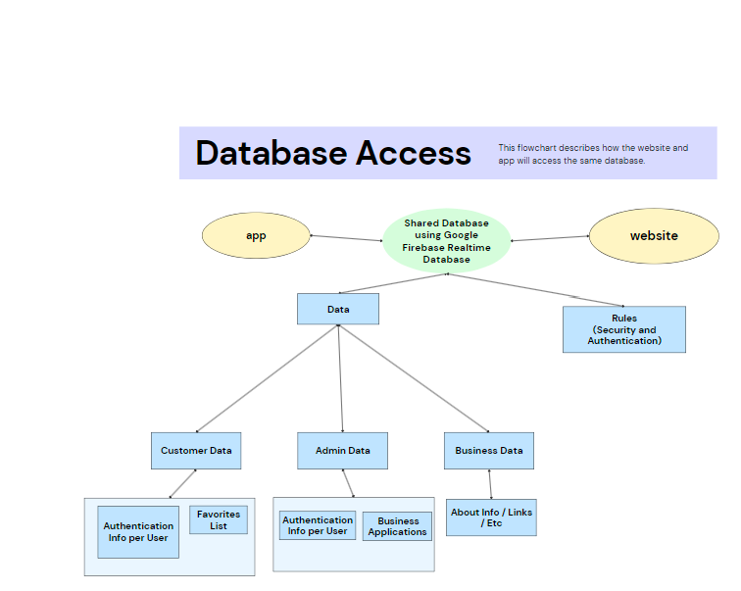Figure 1: Flowchart Database Access
Website Flowchart (Below)
The website is built with a customer login and an admin login in. The customer log in will allow the user to create an account or sign up. After the user will be redirected to the home page which allows the user to either view their profile or click on a tab they would like to view. Some of the functionalities that will be included are customer profiles, login ability, create favorites, share on social media, message businesses directly with feedback, comment on business pages, and to have a favorites list. The admin login will allow the stakeholders to manage the business and check to see if new businesses have applied.
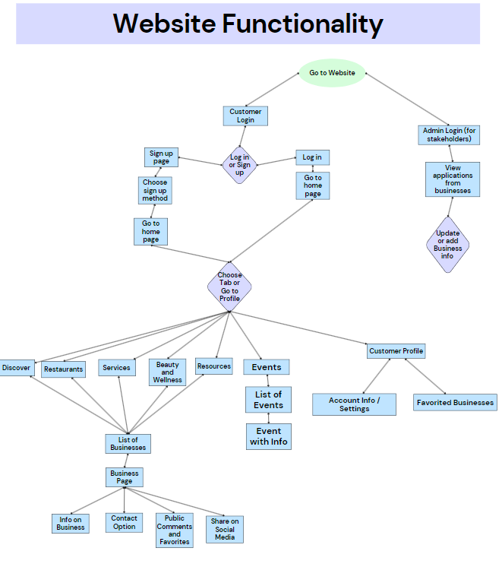
Figure 2: Flowchart of Website Functionality

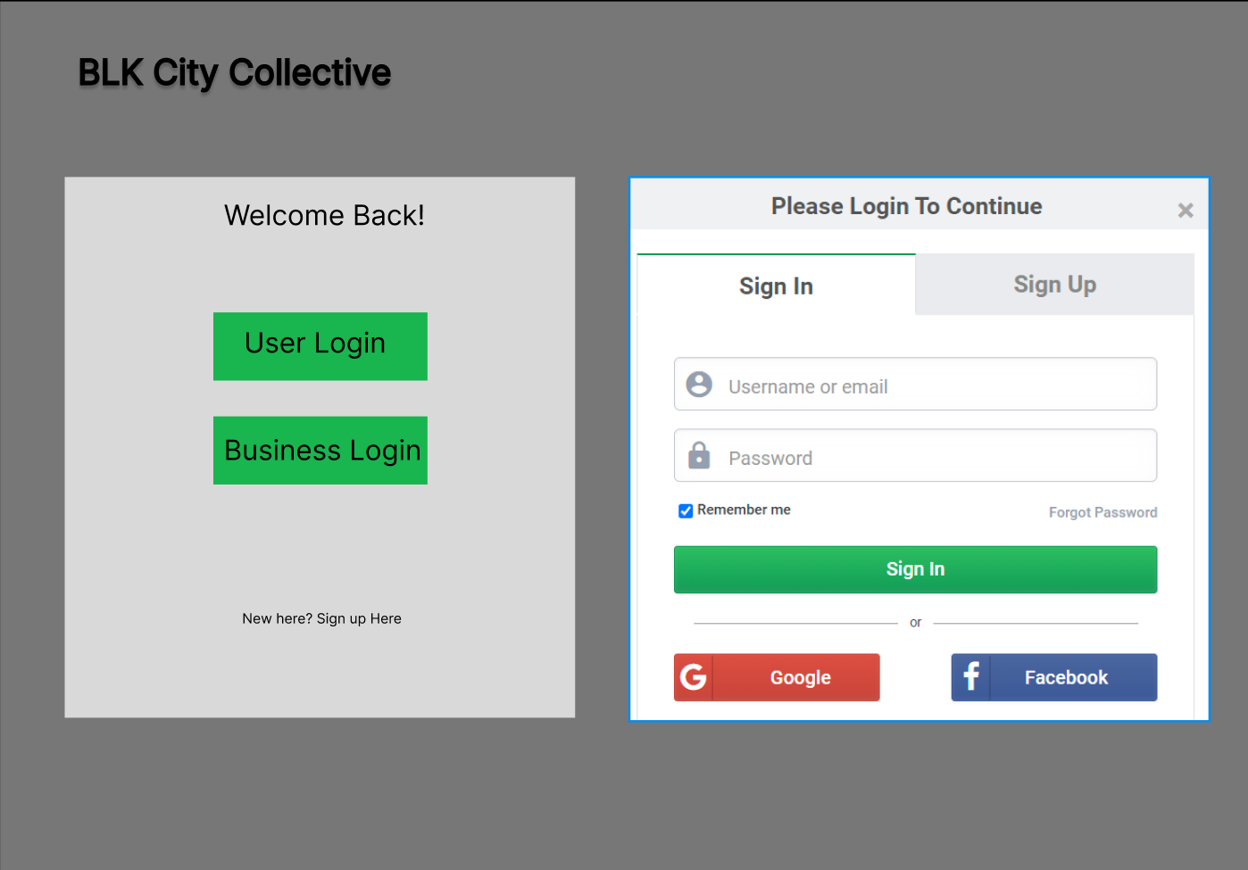
Above is an example of the two login pages that would appear when you first go to the website. One button redirects the user to their appropriate login. There's a login page for businesses and a login page for general users/customers.
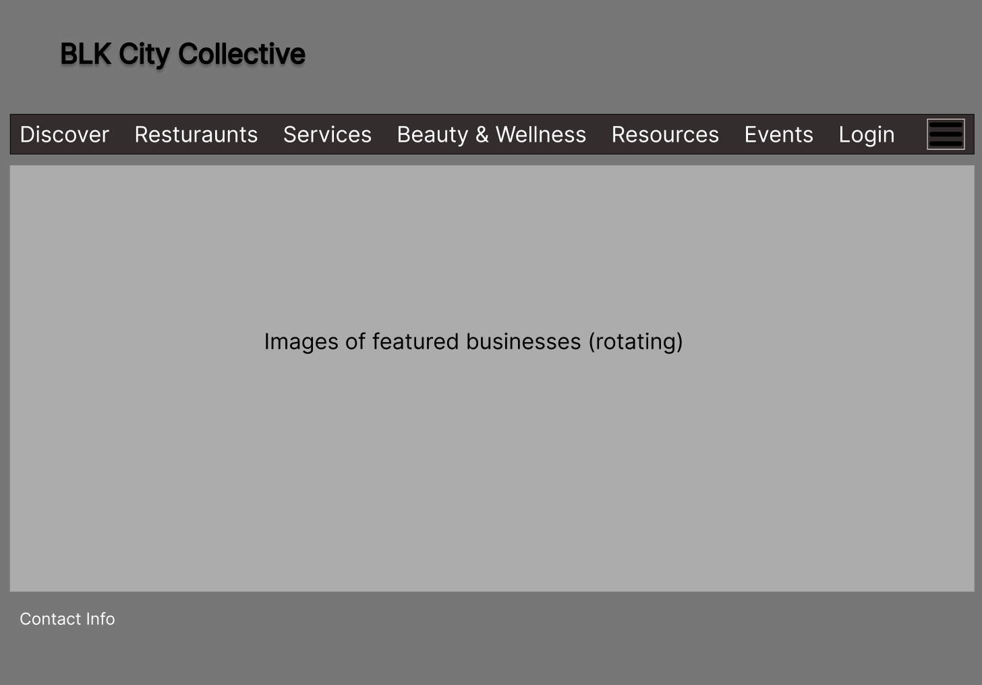
The above image is the home page. The home page is what the user sees when they login and open the MKE Black Website. Attached above we have a sample demo of our home page with all the interactivity shown in the wireframe. The user is given the option to visit any of the seven pages by pressing the respective buttons displayed on the screen since it contains a banner which will link the user to other parts of the site. It also is showcasing some of the businesses on the featured businesses section.

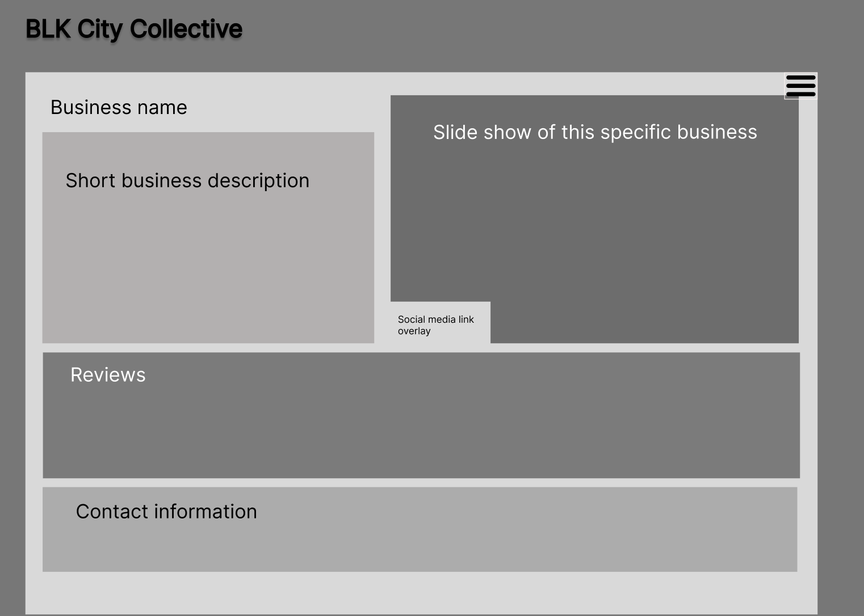
Here is a draft of the type of content that could appear on a page for any given business. There's room for images, a business description, user reviews of the business, and a way to get in contact with the business itself. The contact information section would also include the location of the business.

